1. 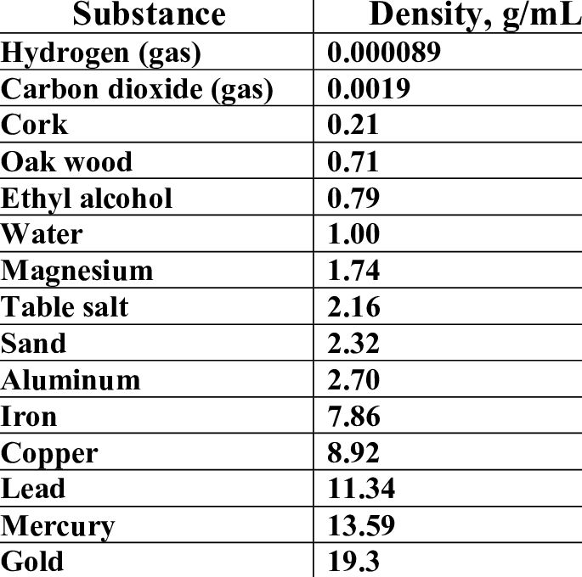Use the density table to the right to match the following   
   substances and densities.  
   1. What is the density of Table Salt?
   2. Density = 1.74, What is the material?
   3. What is the substance with the greatest density?
   4. Is the density of alcohol greater or less than water?
   5. Do gasses have a density?
2. Use density to explain why wood floats in water?
3. Since plastic floats in water, would you expect its density to be greater or less than 1.00 g/ml? (Explain your answer.)
4. What do you think would be the density of a rock? (Hint: Rocks contain sand and aluminum.)